Using Kafka Logs – Video5

* **Go to logs folder of kafka**

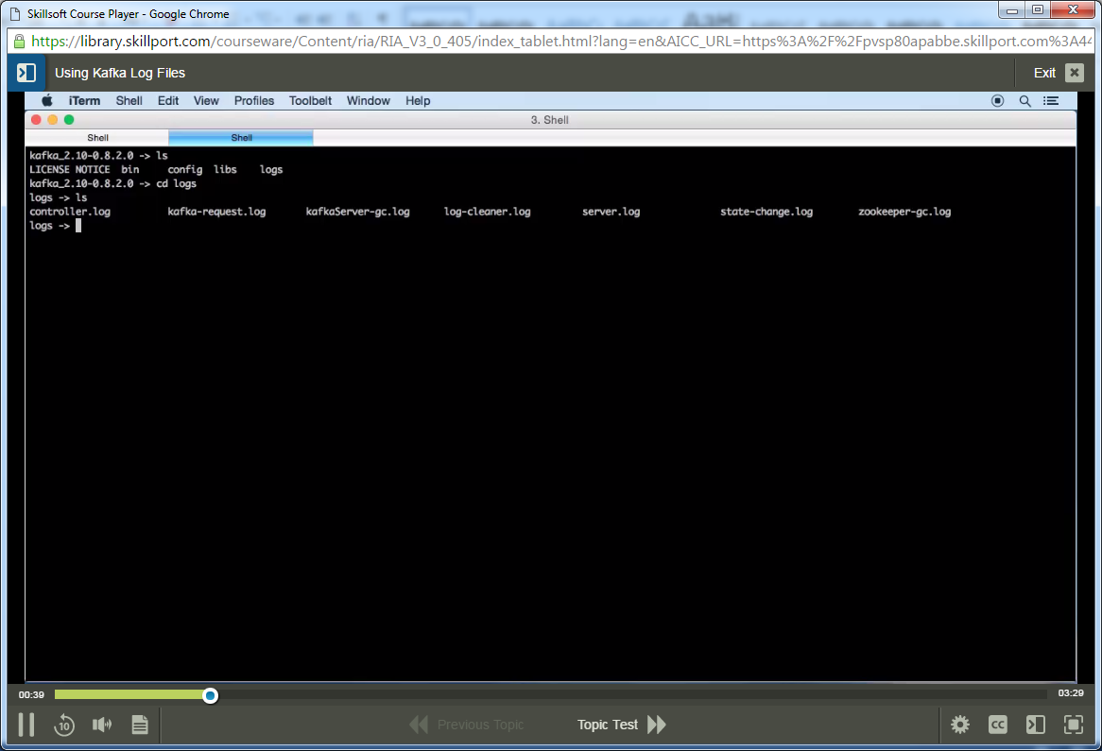

Check out all logs inside logs folder of kafka